Swiggy Data Analysis

USE swiggydb

SELECT * FROM Swiggy_Data

WE HAVE 4 STEPS FOR ANALYSIS:-

Import data
Filter data
Process data
Analyse data

DATA VALIDATION AND CLEANING

NULL CHECK

SELECT
SUM(CASE WHEN state IS NULL THEN 1 ELSE 0 END) AS null_state,
SUM(CASE WHEN City IS NULL THEN 1 ELSE 0 END) AS null_city,
SUM(CASE WHEN Order_date IS NULL THEN 1 ELSE 0 END ) AS null_order,
SUM(CASE WHEN restaurant_name IS NULL THEN 1 ELSE 0 END) AS null_restaurant,
SUM(CASE WHEN location IS NULL THEN 1 ELSE 0 END) AS null_location,
SUM(CASE WHEN category IS NULL THEN 1 ELSE 0 END) AS null_category,
SUM(CASE WHEN dish_name IS NULL THEN 1 ELSE 0 END) AS null_dish_name,
SUM(CASE WHEN price_INR IS NULL THEN 1 ELSE 0 END) AS null_price,
SUM(CASE WHEN Rating IS NULL THEN 1 ELSE 0 END) AS null_rating,
SUM(CASE WHEN Rating_count IS NULL THEN 1 ELSE 0 END) AS null_count
FROM swiggy_data

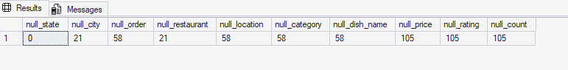

EMPTY STRINGS

SELECT*FROM swiggy_data
WHERE
State=''OR city=''OR Order_date=''OR Restaurant_Name=''OR Location=''OR Category=''OR Dish_name='' OR Price_INR=''
OR Rating=''OR Rating_Count=''

DUPLICATE DETECTION

SELECT
State,city,order_date,Restaurant_name,Location,Category,Dish_name,Price_INR,Rating,Rating_Count,
COUNT(*) AS Duplicate_count
FROM swiggy_data
GROUP BY State,city,order_date,Restaurant_name,Location,Category,Dish_name,Price_INR,Rating,Rating_Count
HAVING COUNT(*)>1

--REMOVE DUPLICATES

WITH CTE AS(
SELECT*,ROW_NUMBER() OVER (PARTITION BY State,city,order_date,Location,Restaurant_name,Category,Dish_name,
Price_INR,Rating,Rating_Count
ORDER BY(SELECT NULL)
) AS RN
FROM swiggy_data
)
DELETE FROM CTE
WHERE RN>

QUESTONS:-

KPI's
Total orders

SELECT COUNT(*) AS Total_orders
FROM Swiggy_orders

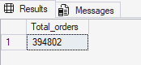

Total Revenue

SELECT FORMAT (
SUM(TRY_CONVERT(DECIMAL(18,4),Price_INR))/1000000,'N2')+'M Million'
AS Total_Revenue
FROM swiggy_orders

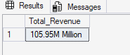

AVG DISH PRICE

SELECT FORMAT(AVG(TRY_CONVERT(DECIMAL(18,4),Price_INR)),'N2')+'INR'
AS Avg_Revenue
FROM Swiggy_orders

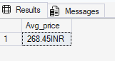

AVG RATING

SELECT FORMAT(AVG(TRY_CONVERT(DECIMAL(2,1),Rating)),'N2')AS Avg_Rating
FROM swiggy_orders

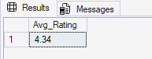

Questions:-

1)MONTHLY ORDER ANALYSIS

SELECT*FROM Date_table

SELECT
d.year,
d.Month,
d.Month_name,
COUNT(*)AS Total_orders
FROM swiggy_orders f
JOIN Date_table d
ON f.date_id=d.date_id
GROUP BY
d.year,
d.month,
d.Month_name
ORDER BY COUNT(*) DESC

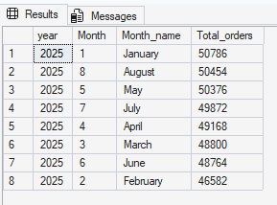

2)QUARTERLY ORDER ANALYSIS

SELECT
d.year,
d.Quarter,
COUNT(*) AS Total_Orders
FROM swiggy_orders f
JOIN date_table d
ON f.date_id=d.date_id
GROUP BY
d.year,
d.quarter
ORDER BY COUNT(*) DESC

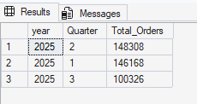

3) WEEKDAYS ANALYSIS

SELECT
DATENAME(WEEKDAY,d.Full_date) AS Day_name,
COUNT(*) AS Total_orders
FROM swiggy_orders f
JOIN Date_table d
ON f.date_id=d.date_id
GROUP BY
DATENAME(WEEKDAY,d.Full_date), DATEPART(WEEKDAY, d.full_date)
ORDER BY DATEPART(WEEKDAY, d.full_date)

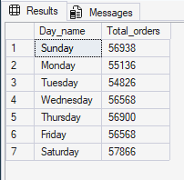

4) YEARLY ORDER ANALYSIS

SELECT
YEAR(d.full_date) AS order_Year,
COUNT(*) AS Total_orders
FROM Swiggy_orders f
JOIN date_table d
On f.date_id=d.date_id
GROUP BY
YEAR(d.full_date)
ORDER BY Order_year ASC

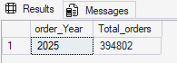

5) TOP 10 CITIESS BY ORDERS

SELECT TOP 10
l.city,
COUNT(f.order_id) AS Total_orders
FROM swiggy_orders f
JOIN Location_table l
ON f.Location_id=l.Location_id
GROUP BY
l.city
ORDER BY Total_orders DESC

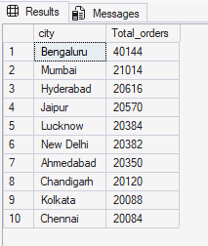

6) BTTOM 5 CITIES BY ORDERS

SELECT TOP 5
l.city,
COUNT(f.order_id) AS Total_orders
FROM swiggy_orders f
JOIN Location_table l
ON f.Location_id=l.Location_id
GROUP BY
l.city
ORDER BY Total_orders ASC

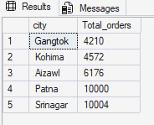

7) REVENUE CONTRIBUTION BY STATES

SELECT
l.State,FORMAT(
SUM(TRY_CONVERT(DECIMAL (18,4), f.Price_INR))/1000000,'N2')+ 'M'
AS Total_Revenue
FROM Swiggy_orders f
JOIN Location_table l
ON l.location_id=f.location_id
GROUP BY l.State
ORDER BY SUM(TRY_CONVERT( DECIMAL(18,4),f.Price_INR)) DESC

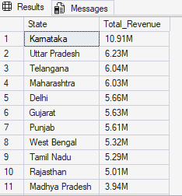

8) TOP 10 RESTURANTS BY ORDERS

SELECT TOP 10
r.Restaurant_name,
COUNT(*) AS Total_orders
FROM Swiggy_orders f
JOIN Restaurant_table r
ON r.Restaurant_id=f.Restaurant_id
GROUP BY r.Restaurant_name
ORDER BY COUNT(*) DESC

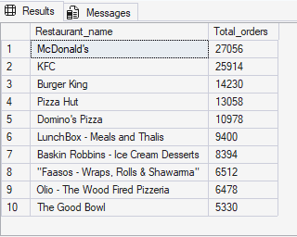

9) TOP 10 RESTAURANTS BY REVENUE

SELECT TOP 10
r. Restaurant_name,
SUM(TRY_CONVERT (DECIMAL(18,2),f.price_INR))
AS Total_revenue
FROM swiggy_orders f
JOIN Restaurant_table r
ON r.restaurant_id=f.restaurant_id
GROUP BY r.restaurant_name
ORDER BY SUM(TRY_CONVERT(DECIMAL(18,2),f.Price_INR)) DESC

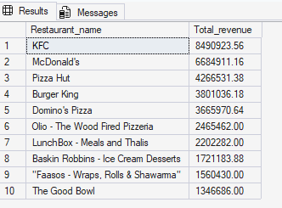

10) TOP CATEGORIES BY ORDERS

SELECT
c.category,
COUNT(*) AS Total_orders
FROM swiggy_orders f
JOIN Category_table c
ON c.Category_id=F.category_id
GROUP BY c.category
ORDER BY COUNT(*) DESC

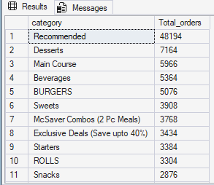

11) MOST ORDERED DISHES

SELECT
d.dish_name,
COUNT(*) AS Total_orders
FROM swiggy_orders f
JOIN Dish_table d
ON d.dish_id=f.dish_id
GROUP BY d.dish_name
ORDER BY Total_orders DESC

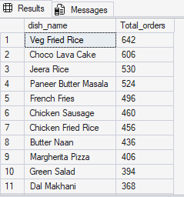

12) CUISINE PERFORMANCE -> ORDERS + AVG RATING

SELECT
c.category,
COUNT(*) AS Total_orders,
AVG(TRY_CONVERT(DECIMAL(2,1), f.rating)) AS Order_rating
FROM swiggy_orders f
JOIN Category_table c
ON c.category_id=f.category_id
GROUP BY c.Category
ORDER BY COUNT(*) DESC

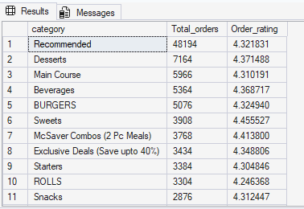

13) PRICE RANGE ORDER

SELECT
CASE
WHEN TRY_CONVERT(DECIMAL(18,4),Price_INR)<100 THEN 'UNDER 100'
WHEN TRY_CONVERT(DECIMAL(18,4),Price_INR)BETWEEN 100 AND 199 THEN '100-199'
WHEN TRY_CONVERT(DECIMAL(18,4),Price_INR)BETWEEN 200 AND 299 THEN '200-299'
WHEN TRY_CONVERT(DECIMAL(18,4),Price_INR)BETWEEN 300 AND 499 THEN '300-499'
ELSE '500+'
END AS Price_range,
COUNT(*) AS Total_orders
FROM Swiggy_orders
GROUP BY
CASE
WHEN TRY_CONVERT(DECIMAL(18,4),Price_INR)<100 THEN 'UNDER 100'
WHEN TRY_CONVERT(DECIMAL(18,4),Price_INR)BETWEEN 100 AND 199 THEN '100-199'
WHEN TRY_CONVERT(DECIMAL(18,4),Price_INR)BETWEEN 200 AND 299 THEN '200-299'
WHEN TRY_CONVERT(DECIMAL(18,4),Price_INR)BETWEEN 300 AND 499 THEN '300-499'
ELSE '500+'
END
ORDER BY Total_orders DESC



